Power BI Report to show sales analytics

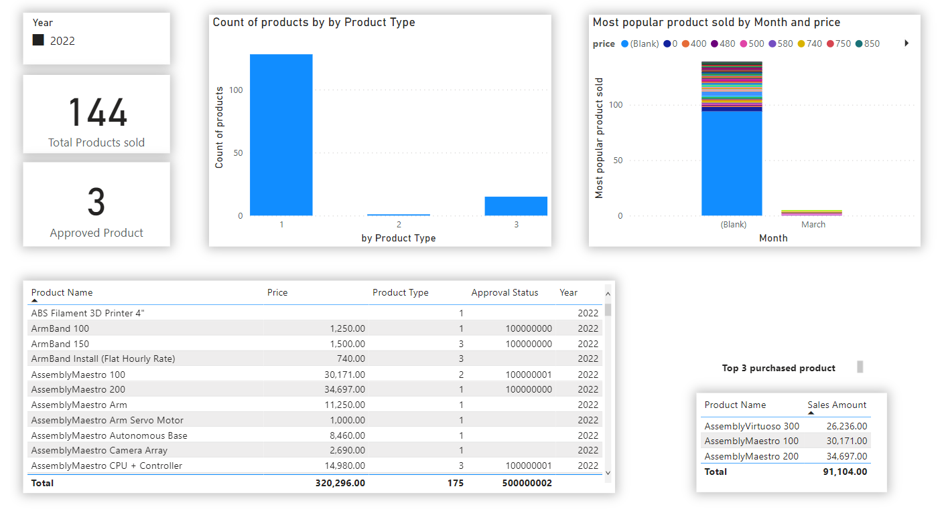

The above power bi report contains the below components

1. A slicer that shows the time frame in years based on record created on date.
2. Card that shows total products sold till now.
3. Card 2 that shows approved product out of all products.

A new measure has been created to calculate the total number of products with status approved.



1. A clustered column chart that displays total number of products sold based of product type field.

Axis -> Product type

Values -> Count of products

1. A stacked column chart that displays total number products sold every month with price value. (Only 1 column because all the records are created in march)

Axis -> Created On (Month)

Legend -> Price

Values -> Product count

1. Table that displays top 3 products based on sales amount.

Apply filtering top n with price

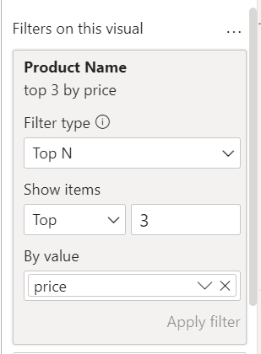

1. A table displays a summary of product related details as below columns.

Product name

Price

Product Type

Approval status

Created year

Report created in Power BI desktop has been pinned to a dashboard in Dynamics CRM.

